System planning
for
Moje javno mnenje
Version 1.0 approved
Prepared by
Zoran Đorđeski, Tomi Raguz, Andrej Koprivec
Računalništvo in informatika FAMNIT
1/10/2013

Use case diagram of the whole system
From the following use case diagram we can see that the system allows three types of users: guests, registered users and moderators. Each role gains additional access to the system. Guest is allowed only to search the content on the site. Registered users gain the possibility to create new categories, posts, polls, petitions, post resources, comments, vote post and comments and are able to report inappropriate content. Moderators inherit all this functionality plus are able to moderate the community.
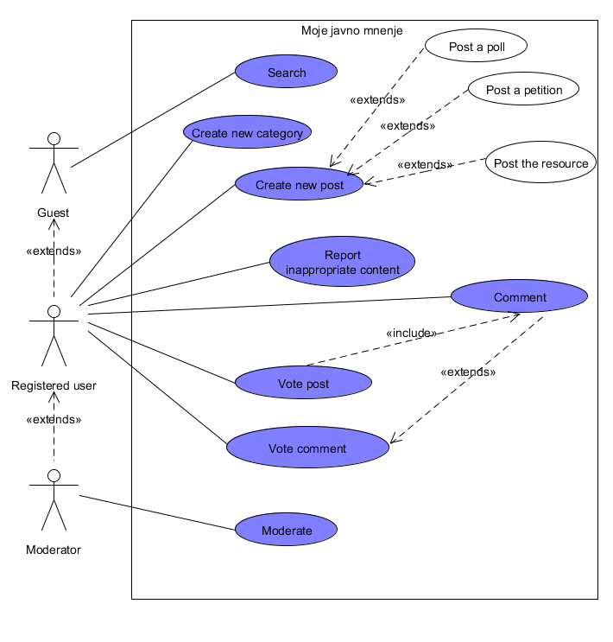
Moderators are the solely responsible for moderating the community by means of responding on complaints made by other users about inappropriate content. They are mostly concerned with reviewing the flagged content, which means that are allowed to supplemented, correct or even entirely delete it.
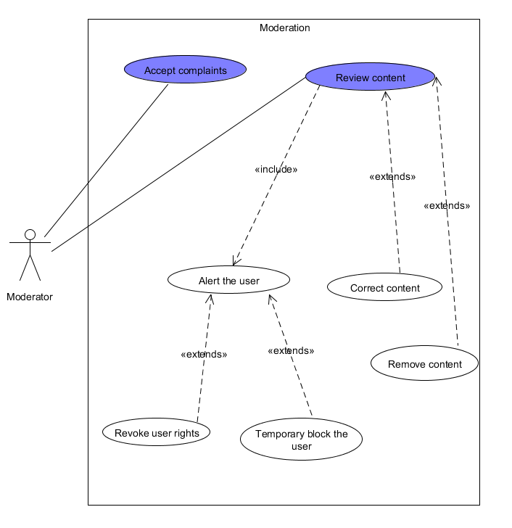
The state diagram represents states of the moderating subsystem and their transitions that occur on specific action. At the beginning the system is in accepting state and on a received complaint transitions in the complaint logging state which is concerned with the logging of the received complaint. The logging state is also the final state but if a the current number of complaints about a specific content is greater or equal then a specified threshold it transitions in the alerting/final state which represent the state that alerts the moderators about the complaint.
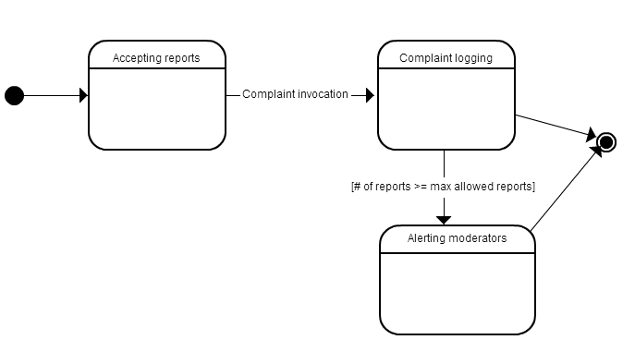
The sequence diagram shows the order of actions that occur when a complaint is issued. The user issue a complaint to the Complaint checking system which in turns logs it and based on the fact of how many complaints were already issued about the same type of problem, it alerts the moderators or not and finally it let the user know about the received complaint.
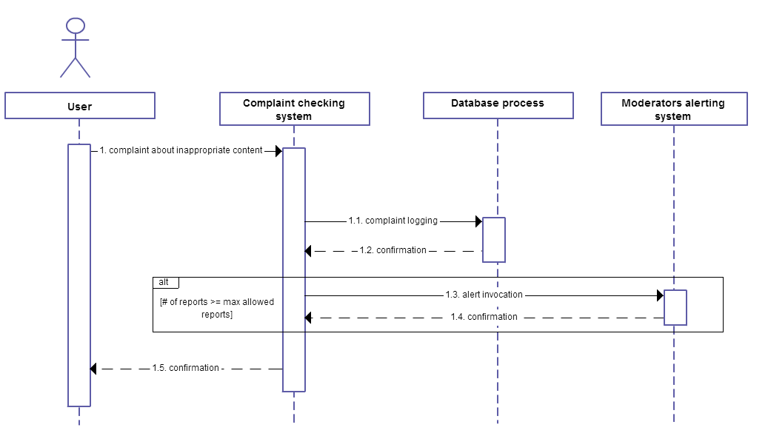
The activity diagram that shows all the steps about the complaint receiving system.
