Pika Povh Mavrič
University of Primorska
Faculty of Mathematics, Natural Sciences
an Information Technologies
Glagoljaška 8,
6000 Koper, Slovenia
+386 70 718 448
89202036@student.upr.si

Machine Learning Model for Predicting Personal Loan Acquisition
Abstract— In modern retail banking, finding the right customers is essential for improving sales and managing marketing costs. The goal of this research was to create a predictive model to estimate how likely a customer is to take out a consumer loan. Using logistic regression in the SAS environment, we analyzed customer data from the first quarter of 2025. On the validation data, the model achieved an AUC value of 0.835, which shows that it has high predictive power. The results show that the most important factors for taking a loan are using the mobile app, owning a credit card, and responding to past marketing campaigns. On the other hand, customers with high deposits are less likely to need a loan.
Key words— Machine Learning, Logistic Regression, Banking Analytics, Predictive Modeling, Consumer Loans, Customer Behavior

INTRODUCTION
The banking industry has changed significantly due to the digital transformation of the last decade. Today, banks collect huge amounts of data every day through mobile apps, credit card transactions, and online payments. This "Big Data" is very valuable, but simply having data is not enough. The main challenge for modern financial institutions is how to turn this information into clear business decisions.
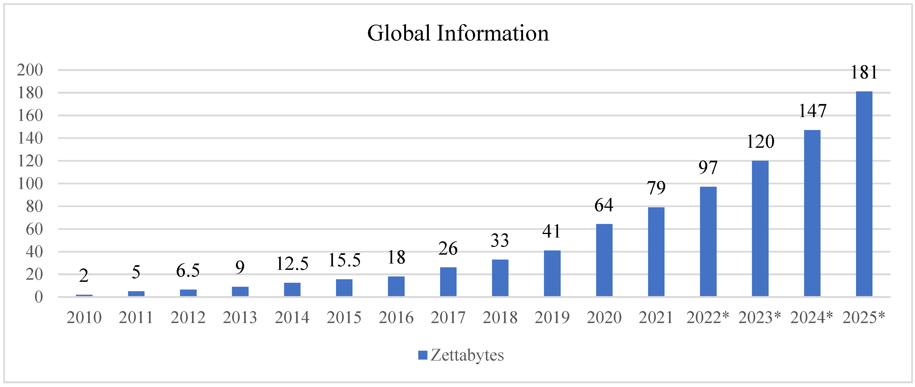
Figure 1: Global amount of information 2010–2025
For many years, banks used mass marketing strategies, where they sent the same product offers to their entire customer base. This approach is no longer effective. Sending irrelevant offers is expensive for the bank and often annoying for the customers, who may feel they are receiving spam. In a competitive market, banks must move from being product-centric to being customer-centric. This means using data to understand what a specific customer needs at the right time.
Machine learning models have become the most effective tool for solving this problem. These algorithms can analyze thousands of customer profiles and find hidden patterns that a human might miss. For example, a model can see how a change in mobile app usage or a specific spending pattern might mean a customer is looking for a loan.
This research focuses on one of the most important products for retail banks, the consumer loan. Because these loans are a key source of profit, predicting who will take one is a high priority. However, the decision to take a loan is complex and depends on many factors, such as income levels, past behavior, and digital engagement.
The goal of this study is to develop a predictive model using logistic regression to identify which customers are most likely to acquire a consumer loan in the following month. By using this model, the bank can focus its resources on a smaller, high-probability group of clients. This not only improves the effectiveness of marketing campaigns but also provides a better experience for the customers by only sending them offers that are relevant to their current financial situation.
The data is real life based and was collected at one of the 4 major banks in Slovenia. The research is based on the data from the first quarter of 2025, but the model can be used for any time period in the past, making it useful for future campaigns creations in the bank.

METHODOLOGY AND DATA PREPARATION

Observation and Target Periods
To build the model, we defined two specific timeframes to ensure a clear distinction between customer behavior and the predicted outcome. The observation period lasted from January to March 2025, during which we collected data on demographics, product usage, and digital activity. The target period was set for April 2025 to see if these same customers actually purchased a consumer loan. The target variable, Target_PL_Apr, is binary, where 1 indicates a loan purchase and 0 indicates no purchase. In the total dataset, there were 566 actual loan purchases during this target month.

Data Cleaning
Data cleaning was a critical step to ensure the reliability of the model and to avoid a problem called data leakage. Data leakage occurs when information from the future or the target period is accidentally included in the training data, which leads to unrealistically high performance results. We excluded any customers who had already acquired a consumer loan during the first quarter of 2025 because their behavior would already show signs of having a loan, which would make the model's predictions less accurate for new customers. Additionally, we limited the study to active retail customers, defined as those who held at least one active product and were not blocked or inactive as of March 31, 2025. This ensured the model was only looking at the bank's current, relevant customer base.

Creating the Analytical Base Table (ABT)
The final Analytical Base Table (ABT) was created by combining three main types of data into one file. This included product data, which tracked the types of accounts held and how long the customer had them, customer data, which included age, gender, and financial metrics like income, and campaign data, which showed how customers responded to marketing in the past. Once the table was ready, we divided the data into two parts using a random split. Seventy percent of the data was used to train the logistic regression model, while the remaining thirty percent was used for validation to test the model's performance on data it had not seen before.

RESULTS

Model Performance and Evaluation
The logistic regression model was evaluated using the validation dataset, which contained 39,147 observations that the model had not seen during the training phase. The most important metric for this study was the C-statistic, also known as the Area Under the Curve (AUC), which reached a value of 0.835. As illustrated in the ROC Curve (Figure 2), the model shows a strong ability to distinguish between buyers and non-buyers, as the curve leans significantly toward the top-left corner. In the banking industry, an AUC score above 0.80 is considered a very strong result, indicating that the model has high discriminatory power and can effectively separate customers who are likely to buy a loan from those who are not. The Score Test for the Global Null Hypothesis also returned a p-value of less than 0.0001, confirming that the relationship between the chosen independent variables and the target variable is statistically significant. These results provide confidence that the model is reliable enough to be used for real-world marketing targeting.

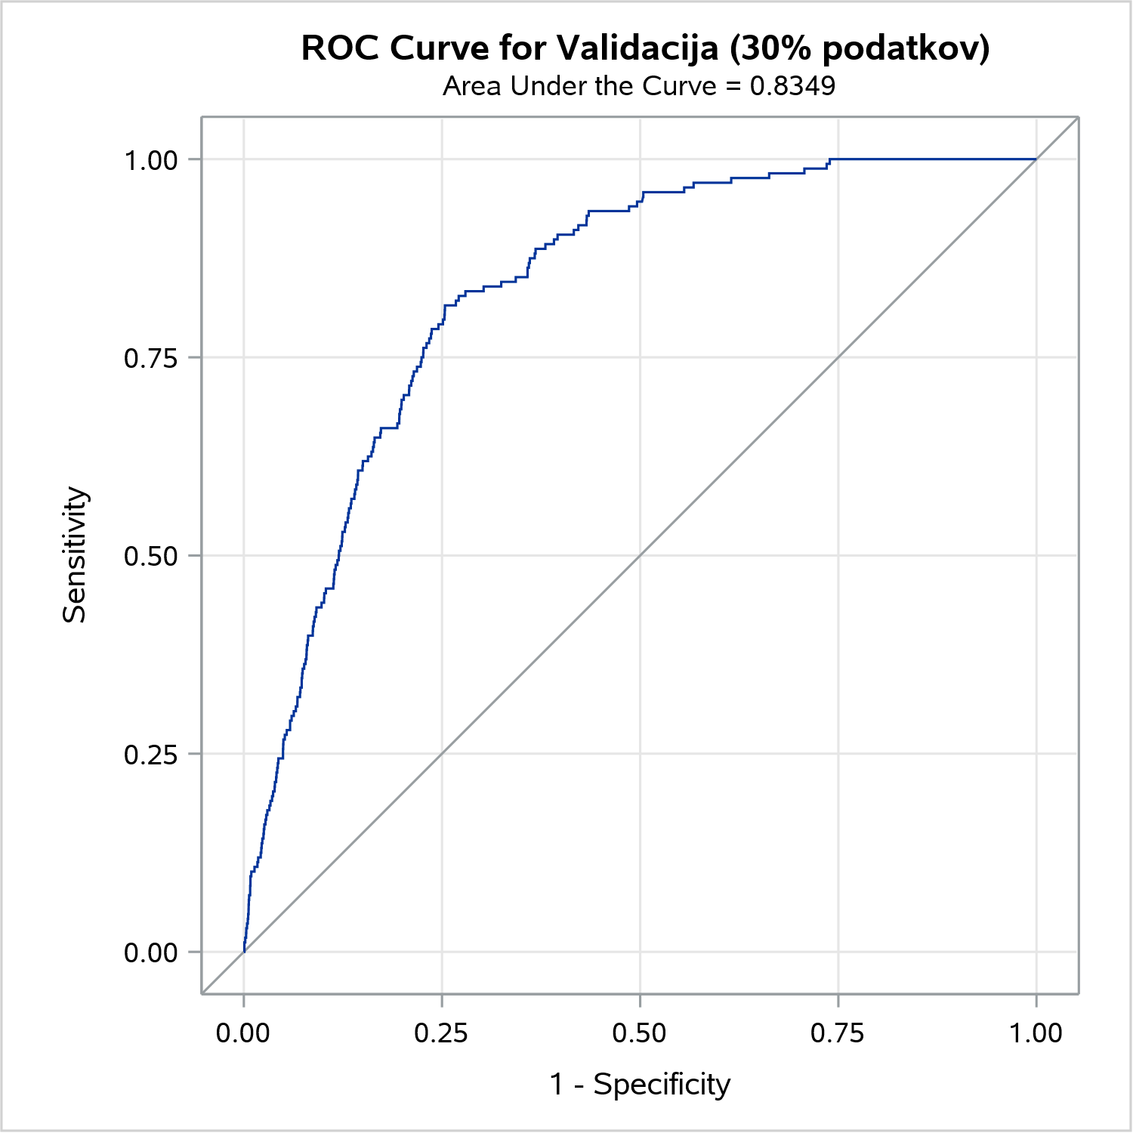
Figure 2: ROC Curve for the Validation Set (AUC = 0.835)

Analysis of Important Variables
The results of the logistic regression and the odds ratio analysis revealed several key factors that drive the probability of acquiring a consumer loan. Digital behavior was the strongest predictor, with customers who regularly use the mobile banking application (Flg_App) showing a significantly higher likelihood of purchase. Additionally, customers who hold an active credit card and frequently use ATMs were found to be more likely to need extra financing compared to those who only use basic debit services. Previous marketing engagement also played a major role, as customers with a history of positive responses to bank offers were much more likely to accept a new loan offer. On the other hand, the model showed that having high managed deposits or savings accounts has a negative impact on loan acquisition, which is logical since these customers can use their own savings instead of borrowing. This confirms that behavioral data related to how a customer uses the bank's services is more predictive than simple demographic data like gender or region.

Decile Analysis and Profiling
To understand the practical value of the model, we ranked all customers into ten equal groups, or deciles, based on their predicted probability of buying a loan. The effectiveness of this ranking is visible in Figure 3, which shows the number of actual buyers in each group. The vast majority of actual loan purchases are concentrated in the first two deciles, while the bottom groups have zero buyers. The first decile, which includes the top 10% of customers with the highest scores, contained 74 actual buyers, while the bottom deciles (9 and 10) contained zero buyers.
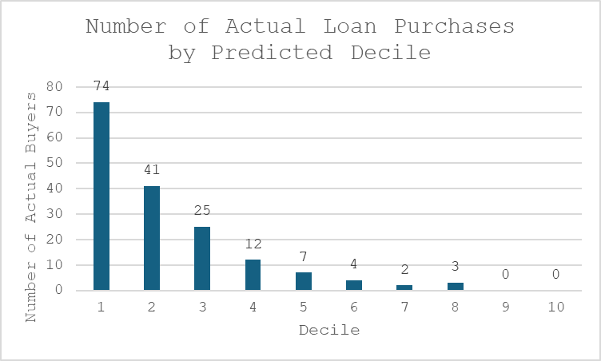
Figure 3: Number of Actual Loan Purchases by Predicted Decile
This massive difference proves that the model is very effective at concentrating the "targets" in the top groups. When profiling the "ideal customer" from the first decile, we found that they are typically between 35 and 50 years old with an average monthly income of approximately 2,172 EUR. They are also highly digital, averaging 36 transactions on the mobile app over a three-month period. In contrast, the tenth decile consists mostly of very young (under 18) or elderly (over 65) customers with almost no digital activity and very low incomes, representing a group that the bank should avoid targeting for this specific product. Table 1 provides a direct comparison between the top and bottom deciles, highlighting the specific characteristics that the model uses to identify high-potential customers.

Metric (Variable) | Decile 1 (High Probability) | Decile 10 (Low Probability)
Avg. Monthly Income | 2,172.20 EUR | 282.60 EUR
Mobile App Usage | 36.6 transactions (in 3 months) | 3.5 transactions (in 3 months)
ATM Usage | 18.9 transactions (in 3 months) | 1.7 transactions (in 3 months)
Primary Age Group | 35 – 50 years (over 57% of group) | Under 18 and Over 65
App User Ratio | 98.4% (3,850 out of 3,914) | 25.8% (1,010 out of 3,914)
Table 1: Profile Comparison of High-Probability vs. Low-Probability Customers

Discussion
The results of this study clearly demonstrate that predictive modeling is a powerful tool for modern retail banking. The primary goal was to see if we could accurately identify future loan purchasers using only historical data, and the model's AUC of 0.835 proves that this is highly effective. This level of accuracy suggests that customer behavior follows specific, repeatable patterns that can be captured by machine learning algorithms like logistic regression.
One of the most interesting findings was the dominance of digital behavioral data over traditional demographic data. While variables like age and income provide a general profile, the actual intent to buy a loan is much more visible through mobile app usage and transaction frequency. Customers who are highly engaged with the bank’s digital platform are not just using a service, but are showing a level of trust and familiarity that makes them more likely to accept additional financial products. This confirms that banks should prioritize digital tracking as a core part of their sales strategy.
The relationship between high deposits and loan acquisition also provides a logical business insight. Customers with large savings are self-sufficient and do not need to pay interest on a loan. By identifying these customers as low probability, the bank can avoid sending them unnecessary loan offers, which prevents customer annoyance and preserves the bank’s brand as a professional financial advisor.
The decile analysis shows the practical value of this research. By focusing only on the first and second deciles, the bank could capture the majority of potential buyers while ignoring 80% of the customer base that is unlikely to convert. This shift from mass marketing to targeted marketing is essential in a digital age where customers are overwhelmed with information. Reducing the volume of outreach while increasing the relevance of each message leads to a much higher return on investment (ROI).
While this model used logistic regression, it is important to note its advantage in terms of interpretability. In the banking sector, it is often necessary to explain why a customer was selected for an offer or why a loan might be suggested. Unlike more complex black box models, logistic regression allows us to see the exact impact of each variable, which is crucial for transparency and regulatory compliance.

Conclusion
This research successfully created a predictive model for consumer loan acquisition with a high degree of accuracy. By using data from the first quarter of 2025 to predict behavior in April 2025, we established a connnection between past transactional patterns and future financial decisions. The model effectively separates the customer base into distinct groups, allowing for highly efficient targeting.
The main findings show that the ideal candidate for a consumer loan is a digitally active individual, typically in the middle aged bracket, with a consistent history of using bank products like credit cards and ATMs. The high AUC score of 0.835 confirms that the variables selected, specifically digital engagement and product tenure, are strong predictors of future sales.
From a business perspective, the implementation of such a model offers two major benefits. First, it significantly reduces marketing costs by narrowing the target audience to a high-probability group. Second, it improves the customer experience by ensuring that marketing communication is relevant and timely. Instead of receiving generic advertisements, customers receive offers that actually match their financial needs and life stage.
For future research, this study could be expanded by including more granular data, such as website clickstream data or real-time geolocation triggers from the mobile app. Additionally, comparing the results of this logistic regression with non-linear models like Random Forests or Gradient Boosting could further refine the prediction accuracy. However, the current model already provides a robust and reliable foundation for the bank to improve its sales efficiency and customer relationship management.

References

Statista. (2021). Worldwide big data and business analytics (BDA) revenue from 2015 to 2022, by segment. https://www.statista.com/statistics/616225/worldwide-big-data-business-analytics-revenue/

Adapted from Volume of data/information created, captured, copied, and consumed worldwide from 2010 to 2024, by A. Holst, 2021, Statista

