Software Requirements Specification
for
Moje javno mnenje
Version 1.0 approved
Prepared by
Zoran Dordeski, Tomi Raguz, Andrej Koprivec
Računalništvo in informatika FAMNIT
11/8/2013
Table of Contents
Table of Contents ii
Revision History ii
1. Introduction 3
1.1 Purpose 3
1.2 Document Conventions 3
1.3 Intended Audience and Reading Suggestions 3
1.4 Product Scope 3
1.5 References 4
2. Overall Description 4
2.1 Product Perspective 4
2.2 Product Functions 4
2.3 User Classes and Characteristics 4
2.4 Operating Environment 4
2.5 Design and Implementation Constraints 5
2.6 User Documentation 5
2.7 Assumptions and Dependencies 5
3. System Features .5
4.1 System Feature 1 6
4.2 System Feature 2 (and so on) .7
5. Other Nonfunctional Requirements .7
5.1 Performance Requirements .7
5.2 Safety Requirements .8
5.3 Security Requirements 8
5.4 Software Quality Attributes 9
5.5 Business Rules 9
6. Other Requirements .
Appendix A: Glossary .
Appendix B: Analysis Models .
Appendix C: To Be Determined List .

Revision History
Name | Date | Reason For Changes | Version

Introduction

Purpose
The purpose of this document is to specify all requirements for the project »Moje javno mnenje«. The main functionality of this project is to allow users to express their views and opinions. The goal is to assist them with an advance system that allows them to search, read, and express their and others opinions.

Document Conventions
Every requirement statement is assumed to have its own priority as to define in most appropriate
way the system behavior. In addition there are various snapshots that represent the user interface.

Intended Audience and Reading Suggestions
This document is intended for any individual user, developer or tester that needs to understand the specifications of the system. Following are the potential uses for each one of the reader types:

Developer: If the developer wants to read, change, modify or add new requirements into the
existing system, he/she must first consult this document, update the requirements in an
appropriate manner and pass the information correctly to the other phases of the development
process.
User: The user of this program reviews the specifications presented in this document determines
if the software has all the suitable requirements and whether the software developer has
implemented all of them.
Tester: The tester needs this document to validate that the initial requirements of this
system actually corresponds to the executable system correctly.

This document contains the necessary requirement, some aspects of the analysis of the
requirements and is organized based on the IEEE Standard for Software Requirements
Specification (IEEE 830-1998).

Product Scope
The project »Moje javno mnenje« tries to tackle the problem related to freedom of speech.
The main functionality of this project is to allow users to express their views and opinions in a coherent, polite and argument based manner. The goal is to assist them with an advance system that allows them to search, read, and express their and others opinions on a particular subject. Users would have to register to be able to access the main functionality of the system, that is create, update, comment, rank and read posts or comments, contrasted with guests who would only be able to read what is already posted by other users.
Every registered user would have a “respect” attribute, which after reaching a certain threshold would allow the system to recognize him/her as a moderator. The user “respect” attribute would increase/decrease by action of other users who positively/negatively react by ranking his/her topics or comments. Moderators would in addition to have access to the main functionality, be able to modify and remove other users content.
The “moderator” subsystems would have to be organic, which means that the system is able to successfully classify moderators on certain criteria which are related to how a user interacts with the community. There would not be any paid or “by hand” selected moderators. The system would be community driven with the help of certain algorithms in the background.

References
This citation is used as a model of reference:
[IEEE Std 830-1998]

Overall Description

Product Perspective

Product Functions
Create a new disscussion:
After sign-in and subscribing to a subforum the user can post new discussions on the subforum.
Hide a discussion:
Special users (moderators) can hide other users discussions and comments.
Filters:
Users and non-users can use filters to search discussions by name, type and/or region.
Tabs:
Users and non-users can use tabs to view most new/rising/top/controversial discussions in a subforum.
Navigation:
Users and non-users can use the navigation map on the mainpage to navigate on the map and reach desired subforum.
Reporting:
Users can use the report button to report a comment or a discussion.

User Classes and Characteristics
Guest: Guest are unregistered users. The only functionality they get is to read various topics.

Registered user: Registered users are allowed to post their subject matter, comment on others opinions and rank content of other users.

Moderator: Every registered user would have a “respect” attribute, which after reaching a certain threshold would allow the system to recognize him/her as a moderator. The user “respect” attribute gets boosted by other users who positively support and rank his topics or comments.

Operating Environment
Project will be a web based application hosted on http://www.hostgator.com/.

Server specifications:
- 32 Core AMD Opteron Processor 6376
- 64GB / 32GB RAM
- 4 Raid 1s
- SSD MySQL

This product can be viewed by any web browser(Firefox, Chrome, Opera, IE, ..).

Design and Implementation Constraints
There are no constraints at this point of time.

User Documentation

Following are the official links, from where you can retrieve more information about the project:
- http://www.hostgator.com

Assumptions and Dependencies
For proper working of the system the assumption and dependencies are listed as follows:
- Working internet connection
- A web browser
- A flash-player plug-in installed in the web-browser in order to view the videos.

3. System Features

3.1 Sign-up:: REQ1

3.1.1 Description and Priority
A user needs to sign up in order to be able to comment, vote or start new discussions.
Priority level=high

3.1.2 Stimulus/Response Sequences
Preconditions: None
User clicks on the sign up option. Sign up form is displayed.
User enters his username, email-id, password and captcha.
An account for the user is created and the user is redirected to his/her homepage.
Postconditions: An account for the user is created.

3.2 System Feature Sign-in::REQ2

3.2.1 Description and Priority
After sign-up, a user can anytime access his/her account by signing in.
Priority level=high

3.2.2 Stimulus/Response Sequences
Preconditions: The user must sign up before sign-in. User clicks on the sign in option.
Sign in form is displayed.
User enters his email-id and password.
If the email-id and password are correct the user is redirected to his homepage.
If the email-id and password are incorrect an error message is displayed.
Postconditions: The user is logged-in into his account.

3.3 System Feature Change profile information::REQ3

3.3.1 Description and Priority
After sign-in users have a provision to add more information about them. They can also set their privacy level to restrict the view of their profile.
Priority=Low

3.3.2 Stimulus/Response Sequences
Preconditions: The user must sign up.
User clicks on profile.
User’s profile is displayed.
User edits his/her profile information and clicks on the save button.
User’s profile information gets saved.
Postconditions:None

3.4 System Feature Subscribing and unsubscribing from a specific subforum::REQ4

3.4.1 Description and Priority
After sign-in the user can browse through the various courses and can subscribe or unsubscribe from a particular subforum.
Priority=High

3.4.2 Stimulus/Response Sequences
Preconditions: The user must sign in before subscribing. User selects a subforum. User needs to be subscribed in order to unsubscribe.
The subforum homepage is displayed.
The user clicks on the subscribe/unsubscribe button if he/she wants to get subscribed/unsubscribed in it.
User gets subscribed/unsubscribed in that particular subforum.
Postconditions: User gets subscribed/unsubscribed in the subforum and can/can’t now see the specific subforum topics on his homepage.

3.5 System Feature Vote::REQ5

3.5.1 Description and Priority
After subscribing to a subforum, user can vote up or vote down specific discussions. For downvoting user has to post a comment with minimum number of words.
User can also vote other users comments.
Priority=High

3.5.2 Stimulus/Response Sequences
Preconditions: The user must sign up and later subscribe to the subforum. User clicks on the up or down vote option.
In case of downvoting the main post (Orignal Poster’s post), a ‘make-a-new-comment’ window displays.
Postconditions: None

3.6 System Feature Create a new discussion::REQ6

3.6.1 Description and Priority
After sign-in and subscribing to a subforum the user can post new discussions on the subforum.
Priority=High

3.6.2 Stimulus/Response Sequences
Preconditions: The user must sign in and later subscribe to a subforum.
User clicks on the desired subforum.
The page for the subforum is displayed.
User posts his/her discussion on the forum.
There are minimum amount of words required.
User selects type of pre-selected discussion type options.
Postconditions:The new discussion is shown in the subforum.

3.7 System Feature Hide a discussion::REQ7

3.7.1 Description and Priority
Special users (moderators) can hide other users discussions and comments.
Priority=High

3.7.2 Stimulus/Response Sequences
Preconditions: User must have special rights for the specific subforum. The status for a moderator is offered by the system.
If user is chosen by the system, he can accept or decline the rights to moderate.
If he accepts, he can hide specific topics or comments.
User must write an explanation to state the reason of his decisions.
Postconditions:Discussion/topic are hidden, seen only in a separate part of the subforum.

3.8 System Feature Filters::REQ8

3.8.1 Description and Priority
Users and non-users can use filters to search discussions by name, type and/or region.
Priority=Medium

3.8.2 Stimulus/Response Sequences
Preconditions: None.
Person clicks on the filter option.
Person writes either the name for discussion title matchup, choses region and/or the type of discussion. Program uses filters to show the positive matches to the search query.
Postconditions:Discussions with positive match to the filters are shown.

3.9 System Feature Tabs::REQ9

3.9.1 Description and Priority
Users and non-users can use tabs to view most new/rising/top/controversial discussions in a subforum.
Priority=Medium

3.9.2 Stimulus/Response Sequences
Preconditions: None.
Person clicks on the desired tab.
Postconditions:Discussion that are newest/most controversial/top are shown by rank.

3.10 System Feature Navigation::REQ10

3.10.1 Description and Priority
Users and non-users can use the navigation map on the mainpage to navigate on the map and reach desired subforum.
Priority=Medium

3.10.2 Stimulus/Response Sequences
Preconditions: None.
Person clicks on the desired location of the map and the map zooms in and shows which subforums exist for that particular area. Person can chose which subforum to be redirected to from there, or click again to get even small area on the map.
Postconditions:Discussion that are in the area are shown by rank.

3.11 System Feature Reporting::REQ11

3.11.1 Description and Priority
Users can use the report button to report a comment or a discussion.
Priority=High

3.11.2 Stimulus/Response Sequences
Preconditions: User must be subscribed to the subforum.
User clicks on the report button.
If enought reports (depending on number of subscribers on the subforum) are given, the moderators are alerted.
Postconditions:Moderators are alerted, comment gets 'minimized', discussion loses ranking.

4. External Interface Requirements

4.1 User Interfaces

4.1.1 User interface for Sign Up or Sign in

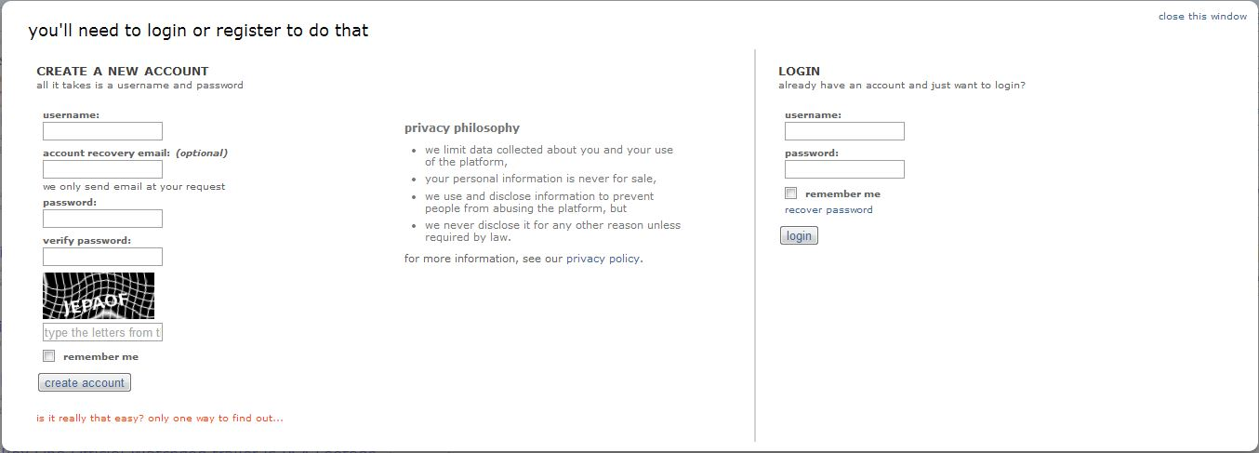

4.1.3 Navigation map
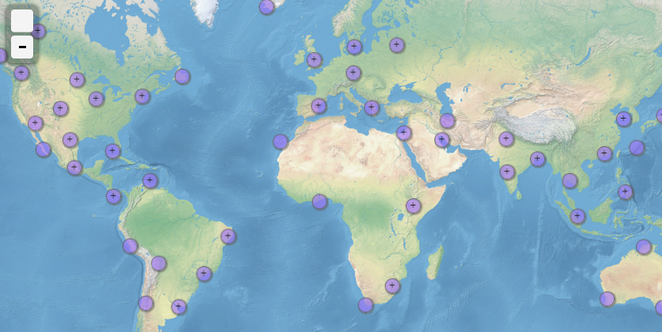

4.1.4 Discussion and comments
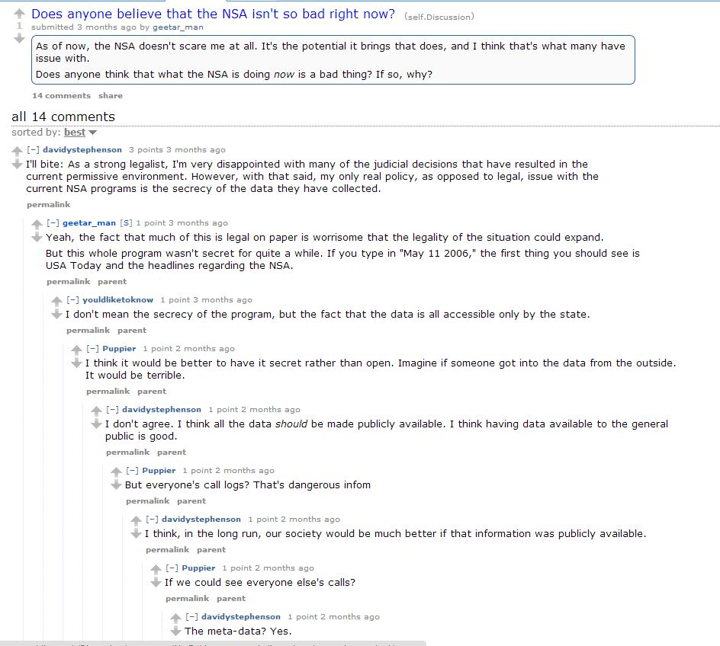

5. Other Nonfunctional Requirements

5.1 Performance Requirements

Performance: In every action-response of the system, there should be no immediate delays. In case of opening windows forms, popping of error messages and saving the settings or sessions the delay should be below 2 seconds. In case of opening databases and computing there should be no delays and the operation should be performed in less than 2 seconds.

5.2 Safety Requirements

Consistency: Checking the fact that all clients must be attached to one server, so there is an appropriate control of the information.

5.3 Software Quality Attributes

- Availability: Checking that the system always has something to function and always pop up error messages in case of component failure.
- Usability: Checking that the system is easy to handle and navigates in the most expected way with no delays. In that case the system program reacts accordingly and transverses quickly between its states.
- Functionality: Checking that the system provides the right tools to support all its features

